Info display must work in 2 options together

LED RS485 Display + HDMI TFT display

**THIS IS HDMI Display picture**

Fixed text we need to write in config file

Parking fixed text write in config file and connection string to database.

If we have 2 parking we enabel just 2 line

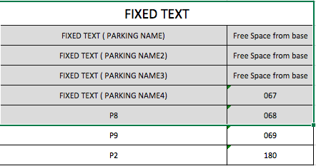

1. Software must after reboot start automaticly and be in full screen
2. Font, size of letter, letter color, becground color, becground image(gif/jpg) must bi configurable

**Config file must have:**

* adjust the window size and dimensions betwin windows standard is 1080P or 720p
* Font (ARIAL BOLD) fixed,
* Font size per box global
* Font colorl per box global
* becground color global

This is Raspbery Pi instalation and HDMI monitor,

if we not use HDMI monitor we use LED display over RS485

Each display have RS485 address and connect paralel over one RS485 communicator ove USB.

If we have 8 parking we use 8 LED display.

LED DISPLAY PICTURE

If you we use 1 display, system must working

